Appendix

**User Interface**

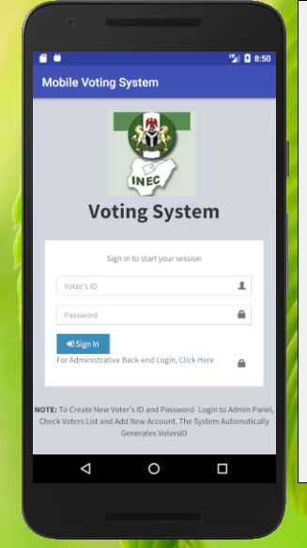

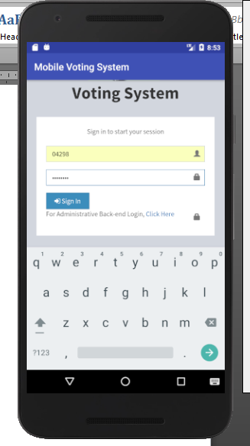

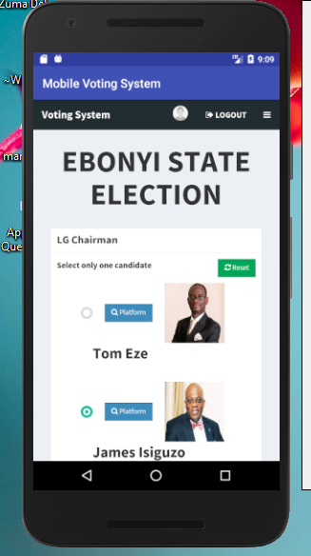

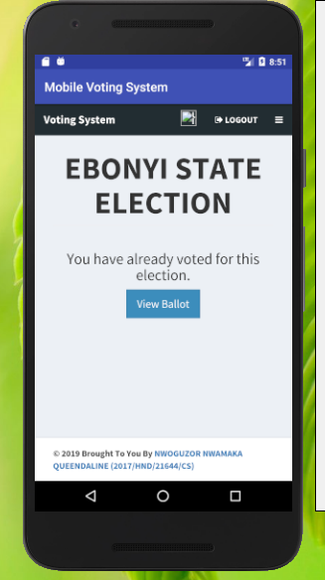

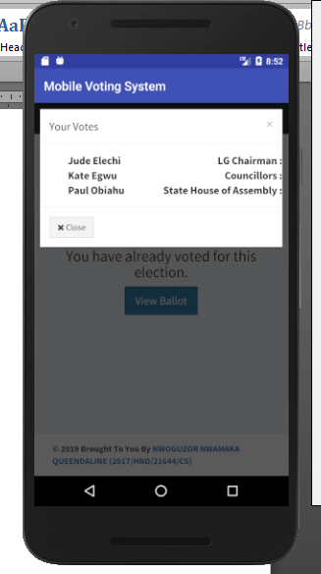

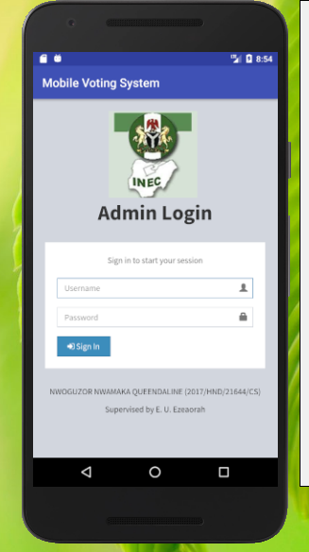

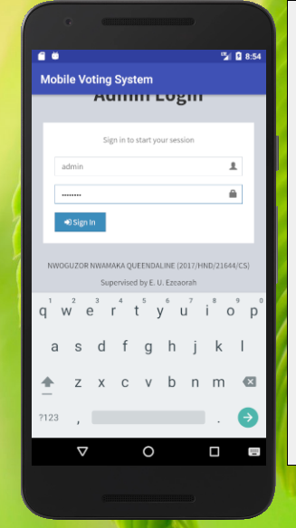

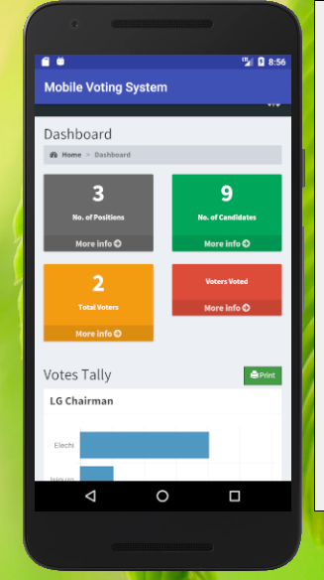

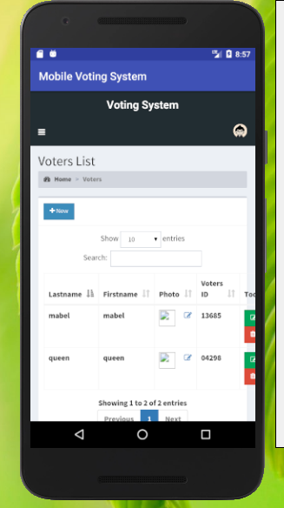

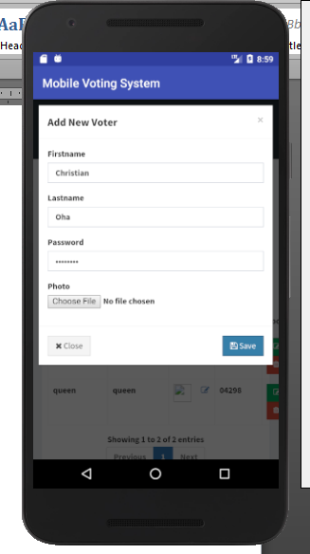

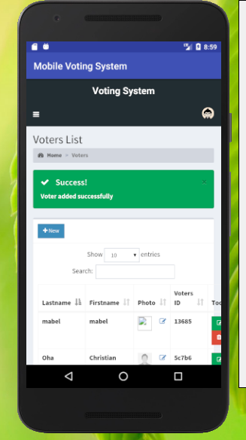

**Source Code**

<?php

session_start();

if(isset($_SESSION['admin'])){

header('location: admin/home.php');

}

if(isset($_SESSION['voter'])){

header('location: home.php');

}

?>

<?php include 'includes/header.php'; ?>

<body class="hold-transition login-page">

<div class="login-box">

<div class="login-logo">

<img src="images/1.jpg" width=40% />

<br />

<b>Voting System</b>

</div>

<div class="login-box-body">

<p class="login-box-msg">Sign in to start your session</p>

<form action="login.php" method="POST">

<div class="form-group has-feedback">

<input type="text" class="form-control" name="voter" placeholder="Voter's ID" required>

<span class="glyphicon glyphicon-user form-control-feedback"></span>

</div>

<div class="form-group has-feedback">

<input type="password" class="form-control" name="password" placeholder="Password" required>

<span class="glyphicon glyphicon-lock form-control-feedback"></span>

</div>

<div class="row">

<div class="col-xs-4">

<button type="submit" class="btn btn-primary btn-block btn-flat" name="login"><i class="fa fa-sign-in"></i> Sign In</button>

</div>

</div>

</form>

</div>

<?php

if(isset($_SESSION['error'])){

echo "

<div class='callout callout-danger text-center mt20'>

<p>".$_SESSION['error']."</p>

</div>

";

unset($_SESSION['error']);

}

?>

</div>

<?php include 'includes/scripts.php' ?>

</body>

<footer>

<p><center><b>NOTE:</b> To Create New Voter's ID and Password- Login to Admin Panel, Check Voters List and Add New Account. The System Automatically Generates VotersID </p></center>

</div>

</html>

**Home Page**

<?php include 'includes/session.php'; ?>

<?php include 'includes/header.php'; ?>

<body class="hold-transition skin-blue layout-top-nav">

<div class="wrapper">

<?php include 'includes/navbar.php'; ?>

<div class="content-wrapper">

<div class="container">

<!-- Main content -->

<section class="content">

<?php

$parse = parse_ini_file('admin/config.ini', FALSE, INI_SCANNER_RAW);

$title = $parse['election_title'];

?>

<h1 class="page-header text-center title"><b><?php echo strtoupper($title); ?></b></h1>

<div class="row">

<div class="col-sm-10 col-sm-offset-1">

<?php

if(isset($_SESSION['error'])){

?>

<div class="alert alert-danger alert-dismissible">

<button type="button" class="close" data-dismiss="alert" aria-hidden="true">&times;</button>

<ul>

<?php

foreach($_SESSION['error'] as $error){

echo "

<li>".$error."</li>

";

}

?>

</ul>

</div>

<?php

unset($_SESSION['error']);

}

if(isset($_SESSION['success'])){

echo "

<div class='alert alert-success alert-dismissible'>

<button type='button' class='close' data-dismiss='alert' aria-hidden='true'>&times;</button>

<h4><i class='icon fa fa-check'></i> Success!</h4>

".$_SESSION['success']."

</div>

";

unset($_SESSION['success']);

}

?>

<div class="alert alert-danger alert-dismissible" id="alert" style="display:none;">

<button type="button" class="close" data-dismiss="alert" aria-hidden="true">&times;</button>

<span class="message"></span>

</div>

<?php

$sql = "SELECT * FROM votes WHERE voters_id = '".$voter['id']."'";

$vquery = $conn->query($sql);

if($vquery->num_rows > 0){

?>

<div class="text-center">

<h3>You have already voted for this election.</h3>

<a href="#view" data-toggle="modal" class="btn btn-flat btn-primary btn-lg">View Ballot</a>

</div>

<?php

}

else{

?>

<!-- Voting Ballot -->

<form method="POST" id="ballotForm" action="submit_ballot.php">

<?php

include 'includes/slugify.php';

$candidate = '';

$sql = "SELECT * FROM positions ORDER BY priority ASC";

$query = $conn->query($sql);

while($row = $query->fetch_assoc()){

$sql = "SELECT * FROM candidates WHERE position_id='".$row['id']."'";

$cquery = $conn->query($sql);

while($crow = $cquery->fetch_assoc()){

$slug = slugify($row['description']);

$checked = '';

if(isset($_SESSION['post'][$slug])){

$value = $_SESSION['post'][$slug];

if(is_array($value)){

foreach($value as $val){

if($val == $crow['id']){

$checked = 'checked';

}

}

}

else{

if($value == $crow['id']){

$checked = 'checked';

}

}

}

$input = ($row['max_vote'] > 1) ? '<input type="checkbox" class="flat-red '.$slug.'" name="'.$slug."[]".'" value="'.$crow['id'].'" '.$checked.'>' : '<input type="radio" class="flat-red '.$slug.'" name="'.slugify($row['description']).'" value="'.$crow['id'].'" '.$checked.'>';

$image = (!empty($crow['photo'])) ? 'images/'.$crow['photo'] : 'images/profile.jpg';

$candidate .= '

<li>

'.$input.'<button type="button" class="btn btn-primary btn-sm btn-flat clist platform" data-platform="'.$crow['platform'].'" data-fullname="'.$crow['firstname'].' '.$crow['lastname'].'"><i class="fa fa-search"></i> Platform</button><img src="'.$image.'" height="100px" width="100px" class="clist"><span class="cname clist">'.$crow['firstname'].' '.$crow['lastname'].'</span>

</li>

';

}

$instruct = ($row['max_vote'] > 1) ? 'You may select up to '.$row['max_vote'].' candidates' : 'Select only one candidate';

echo '

<div class="row">

<div class="col-xs-12">

<div class="box box-solid" id="'.$row['id'].'">

<div class="box-header with-border">

<h3 class="box-title"><b>'.$row['description'].'</b></h3>

</div>

<div class="box-body">

<p>'.$instruct.'

<span class="pull-right">

<button type="button" class="btn btn-success btn-sm btn-flat reset" data-desc="'.slugify($row['description']).'"><i class="fa fa-refresh"></i> Reset</button>

</span>

</p>

<div id="candidate_list">

<ul>

'.$candidate.'

</ul>

</div>

</div>

</div>

</div>

</div>

';

$candidate = '';

}

?>

<div class="text-center">

<button type="button" class="btn btn-success btn-flat" id="preview"><i class="fa fa-file-text"></i> Preview</button>

<button type="submit" class="btn btn-primary btn-flat" name="vote"><i class="fa fa-check-square-o"></i> Submit</button>

</div>

</form>

<!-- End Voting Ballot -->

<?php

}

?>

</div>

</div>

</section>

</div>

</div>

<?php include 'includes/footer.php'; ?>

<?php include 'includes/ballot_modal.php'; ?>

</div>

<?php include 'includes/scripts.php'; ?>

<script>

$(function(){

$('.content').iCheck({

checkboxClass: 'icheckbox_flat-green',

radioClass: 'iradio_flat-green'

});

$(document).on('click', '.reset', function(e){

e.preventDefault();

var desc = $(this).data('desc');

$('.'+desc).iCheck('uncheck');

});

$(document).on('click', '.platform', function(e){

e.preventDefault();

$('#platform').modal('show');

var platform = $(this).data('platform');

var fullname = $(this).data('fullname');

$('.candidate').html(fullname);

$('#plat_view').html(platform);

});

$('#preview').click(function(e){

e.preventDefault();

var form = $('#ballotForm').serialize();

if(form == ''){

$('.message').html('You must vote atleast one candidate');

$('#alert').show();

}

else{

$.ajax({

type: 'POST',

url: 'preview.php',

data: form,

dataType: 'json',

success: function(response){

if(response.error){

var errmsg = '';

var messages = response.message;

for (i in messages) {

errmsg += messages[i];

}

$('.message').html(errmsg);

$('#alert').show();

}

else{

$('#preview_modal').modal('show');

$('#preview_body').html(response.list);

}

}

});

}

});

});

</script>

</body>

</html>

**Submit Ballot Page**

<?php

include 'includes/session.php';

include 'includes/slugify.php';

if(isset($_POST['vote'])){

if(count($_POST) == 1){

$_SESSION['error'][] = 'Please vote atleast one candidate';

}

else{

$_SESSION['post'] = $_POST;

$sql = "SELECT * FROM positions";

$query = $conn->query($sql);

$error = false;

$sql_array = array();

while($row = $query->fetch_assoc()){

$position = slugify($row['description']);

$pos_id = $row['id'];

if(isset($_POST[$position])){

if($row['max_vote'] > 1){

if(count($_POST[$position]) > $row['max_vote']){

$error = true;

$_SESSION['error'][] = 'You can only choose '.$row['max_vote'].' candidates for '.$row['description'];

}

else{

foreach($_POST[$position] as $key => $values){

$sql_array[] = "INSERT INTO votes (voters_id, candidate_id, position_id) VALUES ('".$voter['id']."', '$values', '$pos_id')";

}

}

}

else{

$candidate = $_POST[$position];

$sql_array[] = "INSERT INTO votes (voters_id, candidate_id, position_id) VALUES ('".$voter['id']."', '$candidate', '$pos_id')";

}

}

}

if(!$error){

foreach($sql_array as $sql_row){

$conn->query($sql_row);

}

unset($_SESSION['post']);

$_SESSION['success'] = 'Ballot Submitted';

}

}

}

else{

$_SESSION['error'][] = 'Select candidates to vote first';

}

header('location: home.php');

?>

**Login Page**

<?php

session_start();

include 'includes/conn.php';

if(isset($_POST['login'])){

$voter = $_POST['voter'];

$password = $_POST['password'];

$sql = "SELECT * FROM voters WHERE voters_id = '$voter'";

$query = $conn->query($sql);

if($query->num_rows < 1){

$_SESSION['error'] = 'Cannot find voter with the ID';

}

else{

$row = $query->fetch_assoc();

if(password_verify($password, $row['password'])){

$_SESSION['voter'] = $row['id'];

}

else{

$_SESSION['error'] = 'Incorrect password';

}

}

}

else{

$_SESSION['error'] = 'Input voter credentials first';

}

header('location: index.php');

?>

**Logout Page**

<?php

session_start();

session_destroy();

header('location: index.php');

?>

**Preview page**

<?php

include 'includes/session.php';

include 'includes/slugify.php';

$output = array('error'=>false,'list'=>'');

$sql = "SELECT * FROM positions";

$query = $conn->query($sql);

while($row = $query->fetch_assoc()){

$position = slugify($row['description']);

$pos_id = $row['id'];

if(isset($_POST[$position])){

if($row['max_vote'] > 1){

if(count($_POST[$position]) > $row['max_vote']){

$output['error'] = true;

$output['message'][] = '<li>You can only choose '.$row['max_vote'].' candidates for '.$row['description'].'</li>';

}

else{

foreach($_POST[$position] as $key => $values){

$sql = "SELECT * FROM candidates WHERE id = '$values'";

$cmquery = $conn->query($sql);

$cmrow = $cmquery->fetch_assoc();

$output['list'] .= "

<div class='row votelist'>

<span class='col-sm-4'><span class='pull-right'><b>".$row['description']." :</b></span></span>

<span class='col-sm-8'>".$cmrow['firstname']." ".$cmrow['lastname']."</span>

</div>

";

}

}

}

else{

$candidate = $_POST[$position];

$sql = "SELECT * FROM candidates WHERE id = '$candidate'";

$csquery = $conn->query($sql);

$csrow = $csquery->fetch_assoc();

$output['list'] .= "

<div class='row votelist'>

<span class='col-sm-4'><span class='pull-right'><b>".$row['description']." :</b></span></span>

<span class='col-sm-8'>".$csrow['firstname']." ".$csrow['lastname']."</span>

</div>

";

}

}

}

echo json_encode($output);

?>

**Admin page**

<?php

session_start();

if(isset($_SESSION['admin'])){

header('location:home.php');

}

?>

<?php include 'includes/header.php'; ?>

<body class="hold-transition login-page">

<div class="login-box">

<div class="login-logo">

<img src="includes/1.jpg" width=40% />

<br />

<b>Admin Login</b>

</div>

<div class="login-box-body">

<p class="login-box-msg">Sign in to start your session</p>

<form action="login.php" method="POST">

<div class="form-group has-feedback">

<input type="text" class="form-control" name="username" placeholder="Username" required>

<span class="glyphicon glyphicon-user form-control-feedback"></span>

</div>

<div class="form-group has-feedback">

<input type="password" class="form-control" name="password" placeholder="Password" required>

<span class="glyphicon glyphicon-lock form-control-feedback"></span>

</div>

<div class="row">

<div class="col-xs-4">

<button type="submit" class="btn btn-primary btn-block btn-flat" name="login"><i class="fa fa-sign-in"></i> Sign In</button>

</div>

</div>

</form>

</div>

<?php

if(isset($_SESSION['error'])){

echo "

<div class='callout callout-danger text-center mt20'>

<p>".$_SESSION['error']."</p>

</div>

";

unset($_SESSION['error']);

}

?>

</div>

<?php include 'includes/scripts.php' ?>

</body>

<footer>

<p><center>NWOGUZOR NWAMAKA QUEENDALINE (2017/HND/21644/CS)<center></p>

<p><center>Supervised by E. U. Ezeaorah<center></p></footer>

</html>